
St John’s Green Primary School
Learn to Live, Live to Learn


Headteacher Mr Simon Billings
Deputy Headteacher Mrs Tina Bourne
Assistant Headteacher Mrs Fiona Bullivant
Assistant Headteacher Mrs Clare Skinner

We are all
writers …

Telephone: 01206 762884 Email: admin@st-johnsgreen.essex.sch.uk Website: http://st-johns-green.eschools.co.uk

26th September 2023

Dear Year 4 Parents

Danbury Residential 2024

I am pleased to be able to provide you with details of our planned residential trip to Danbury. The dates of the visit are Monday 22nd April to Thursday 25th April 2024. The cost of this trip is £190.00, which covers the transport, accommodation and organised activities for your child.
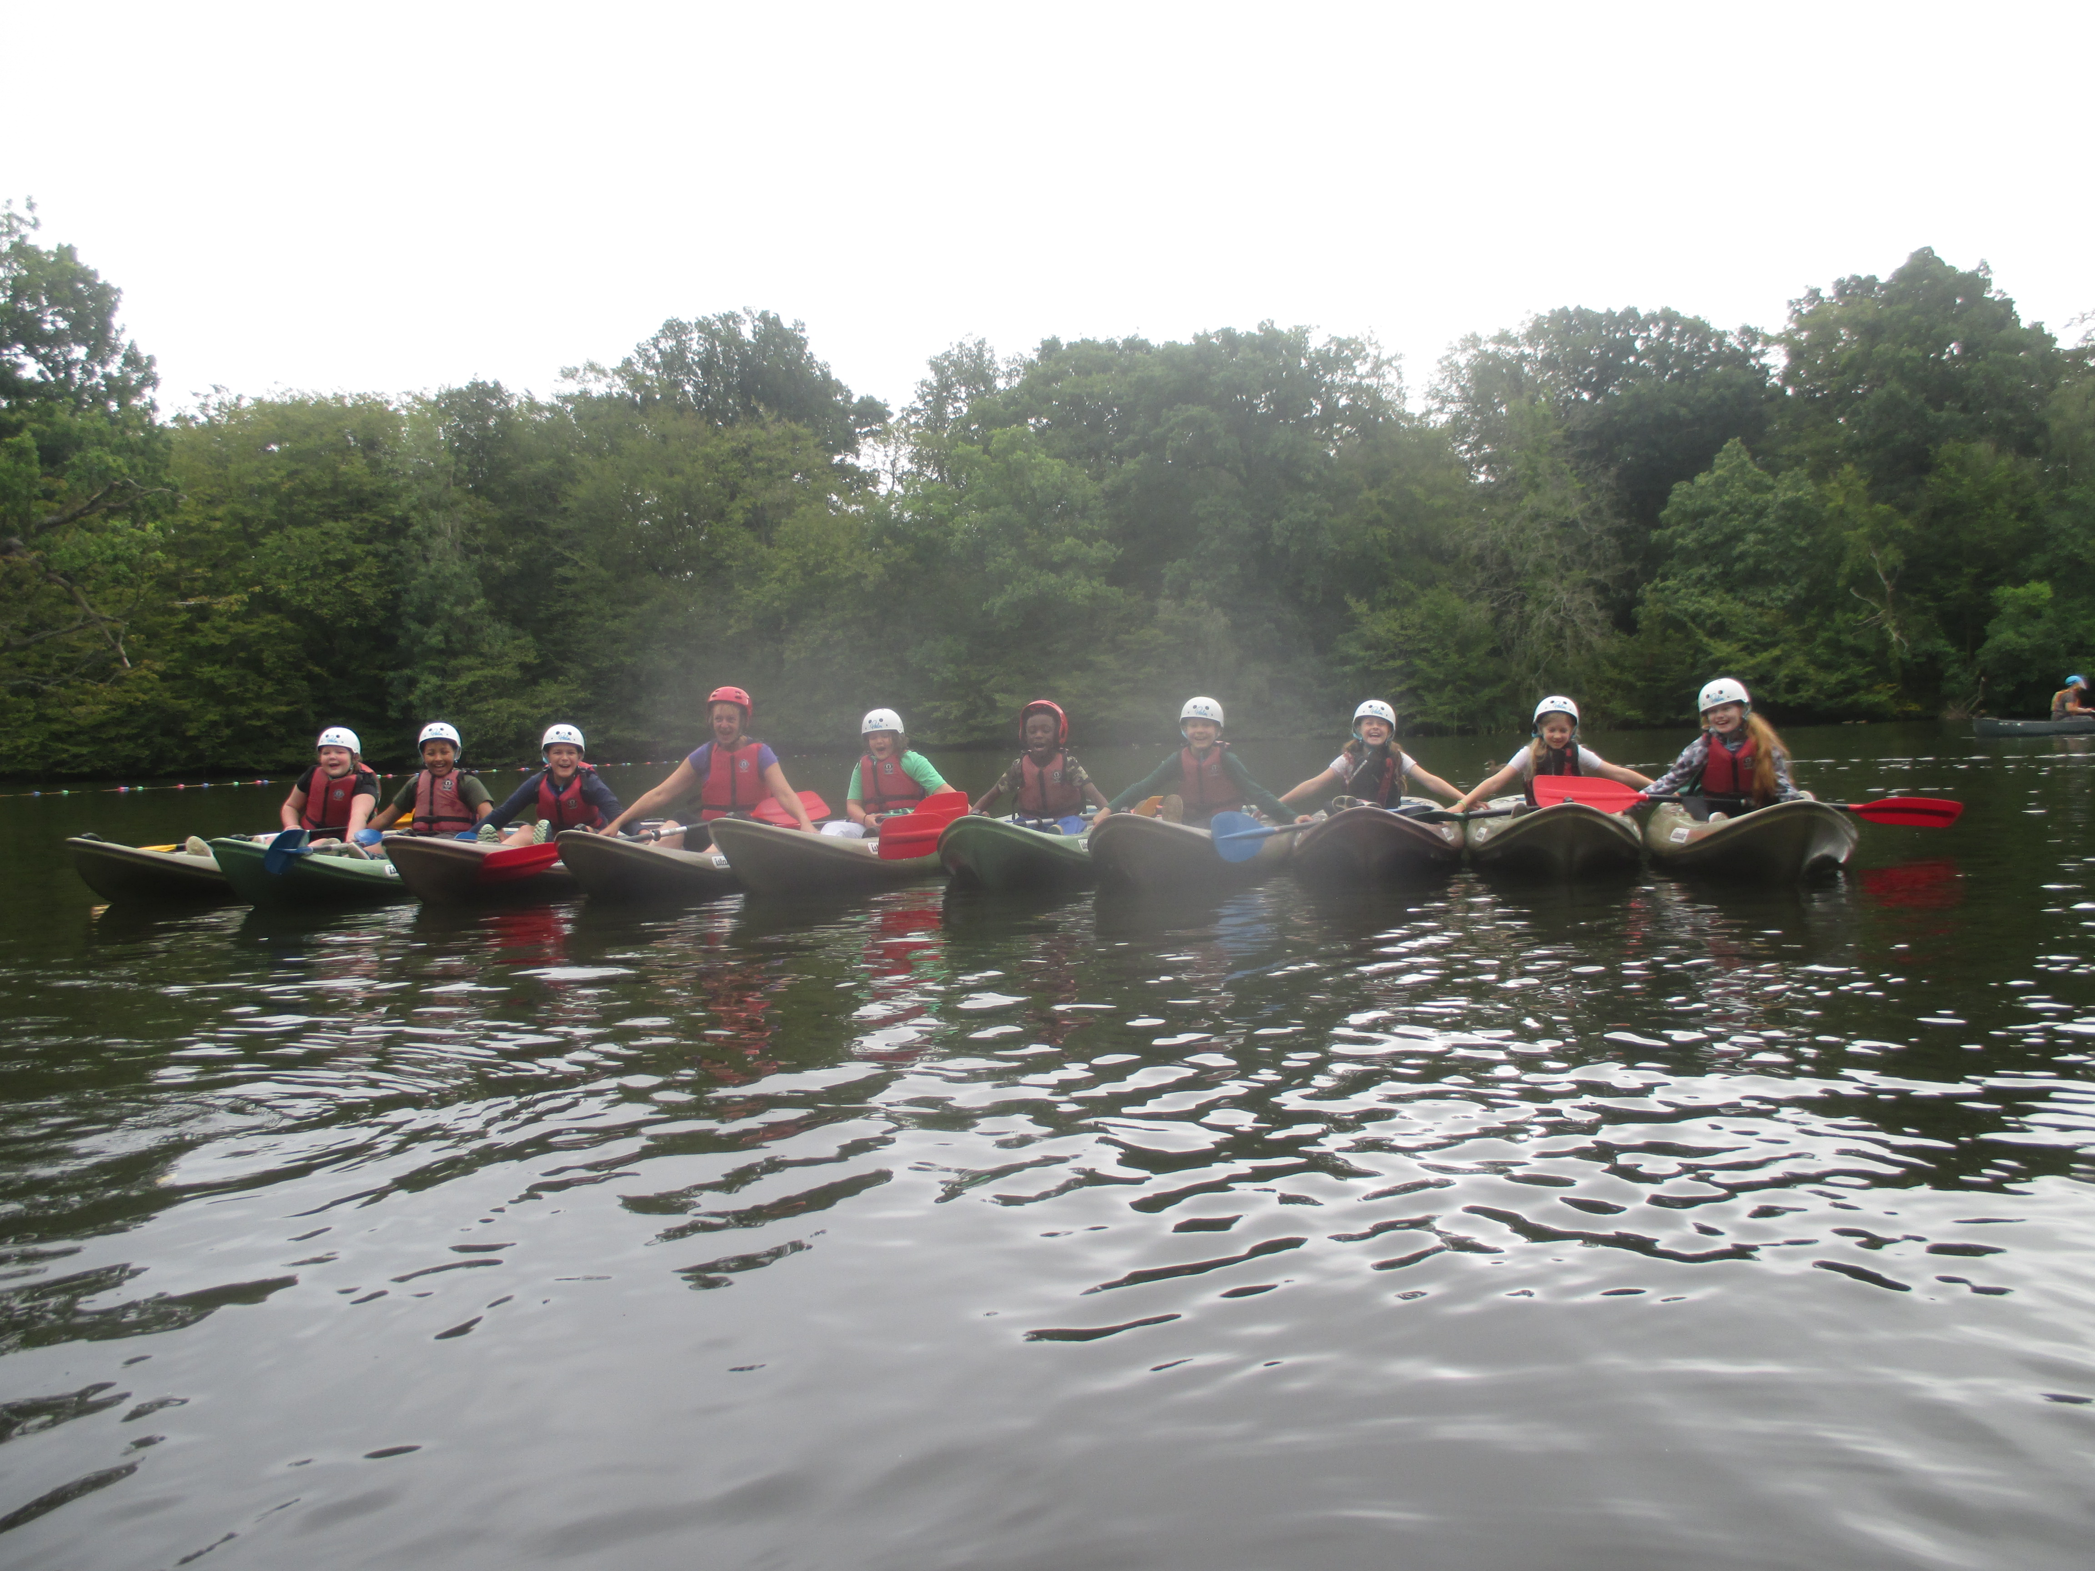

As you are probably aware, our Year 6 pupils take part in a residential for a week during their first term and this shorter trip for Year 4 pupils will introduce the children to the experience of a residential. The school has contributed towards the cost of this residential by accessing Sports Funding to cover the cost of the activity fees, to enable as many Year 4 children as possible to take part. A subsidy of £126.50 per pupil has enabled the School to reduce the costs to parents from £316.50 to £190.00 for this trip.

Please find below the dates when your payments are due to be paid for the Danbury trip:

• A non-refundable deposit of £50.00 needs to be paid by October 20th 2023
• Installment 2 - £25.00 is due by November 24th 2023
- Installment 3 - £25.00 is due by December 20th 2023
- Installment 4 - £30.00 is due by January 19th 2024
- Installment 5 - £30.00 is due by February 16th 2024
• The final payment of £30.00 needs to be paid by March 22nd 2024

Please assist the school by making the payments by the dates listed above. If we do not meet the terms and conditions of the Danbury booking arrangements, we are at risk of losing our reservation for April.

Should your child (or you) change your minds and decide they want to go on the residential trip, then it will be necessary to pay the non-refundable deposit as well as any installments that should have been paid so far. For example, if a decision is made in the January to go on the trip, payments for the deposit (£50.00) plus installment 2 (£25.00), plus installment 3 (£25.00) plus installment 4 (£30.00) – totaling £130.00, would need to be paid in one amount in order to book a place with Danbury.

For children currently entitled to free school meals, there will be a further reduction to the trip cost of £190.00. These parents will receive a letter confirming this separately but the £50.00 non-refundable deposit is still required to book your child’s place.

The school will use receipt cards to record the payments made by parents for their child’s trip; this system has proved to be very successful in previous years. The Office staff will prepare a record card for each child and these cards will be stored in the office. Any payments made will be written on to the savings cards immediately, so that an up to date total of the amount paid is maintained.

Please pay for the Residential trip using the school’s online payment system, but please be aware that you will have to pay as per the instalments listed. Should you have any queries, please contact the school office regarding this.

If you would like your child to travel to Danbury in April 2024, please complete and sign the slip below and return to the office with the £50.00 non-refundable deposit. Unfortunately, it is not possible for the school to reserve a place for your child until the deposit has been paid. If parents are keen for their child to go but are struggling financially, please contact the school. The deposit cannot be paid on your behalf, but there are other funding streams we have been able to access in the past to support children attending.

The experiences they will have whilst there, will stay with them for a very long time – and the further reality is that it is three nights with one less child at home…
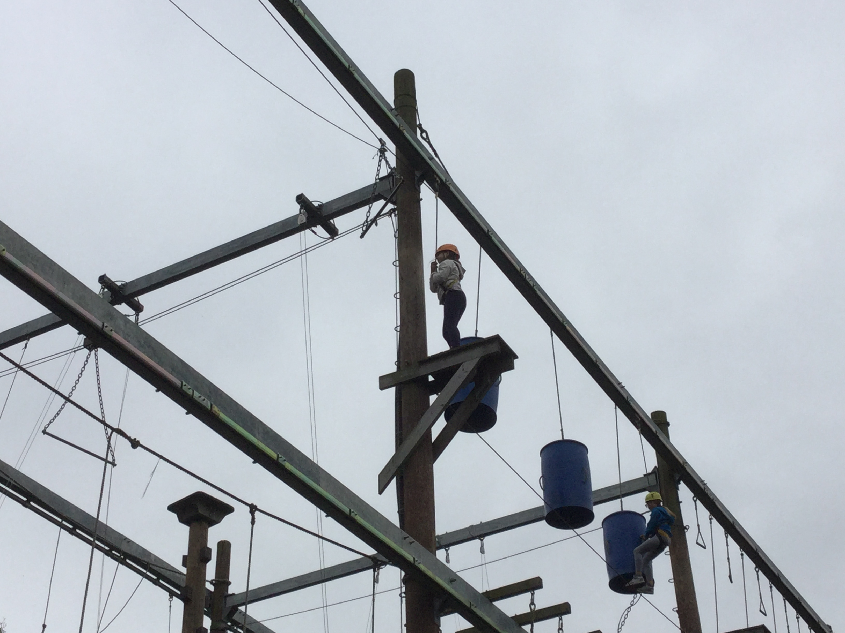

Kind regards
Simon Billings
Head Teacher

Danbury Residential

Monday 22nd to Thursday 25th April 2024

Child’s Name ____________________________________

Child’s Class _____________________________________

I would like my child to travel to Danbury from 22nd April to 25th April 2024 and I agree to pay the installments as detailed in this letter.

Name of Parent/Carer __________________________________________

Signature _____________________________________________________

